**Week 4 Progress**

**What has been done for this week:**

* **Nav bar**

1. A nav bar was implemented for easy navigation to the dynamic pages of the react app. This was done with bootstrap CSS styling. Here is a screen snip of the nav bar below.

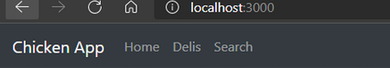

* **Router navigation**

1. Navigation from the different pages was implemented. Allows the user to navigate through the different pages of the app.

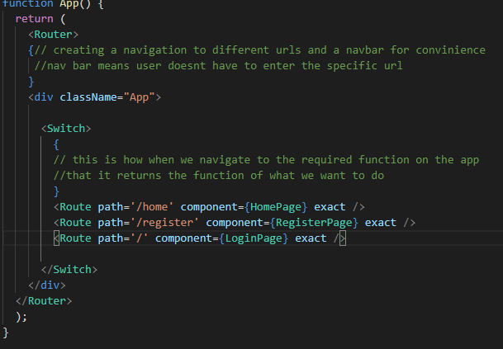

* **Home page**

1. A home page was created. Here is a screenshot below with some hard-coded information implemented in order to test the design and ensure that it works.

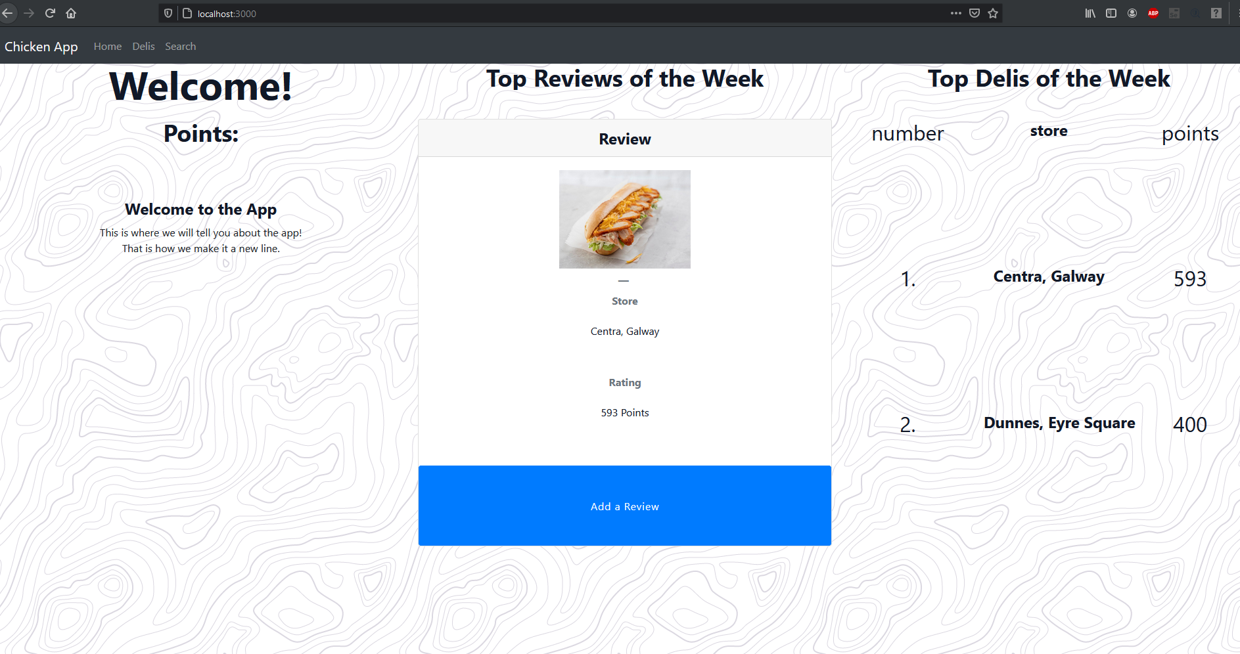

* **Week 4 Outline document:**

1. Document outlining the overall progress, the plan for the coming week etc.